ASSIGNMENT: 4

- Draw a labeled diagram of a Cat6 Ethernet cable, showing the color order of wires in the T568B standard and labeling the RJ-45 connector pins.

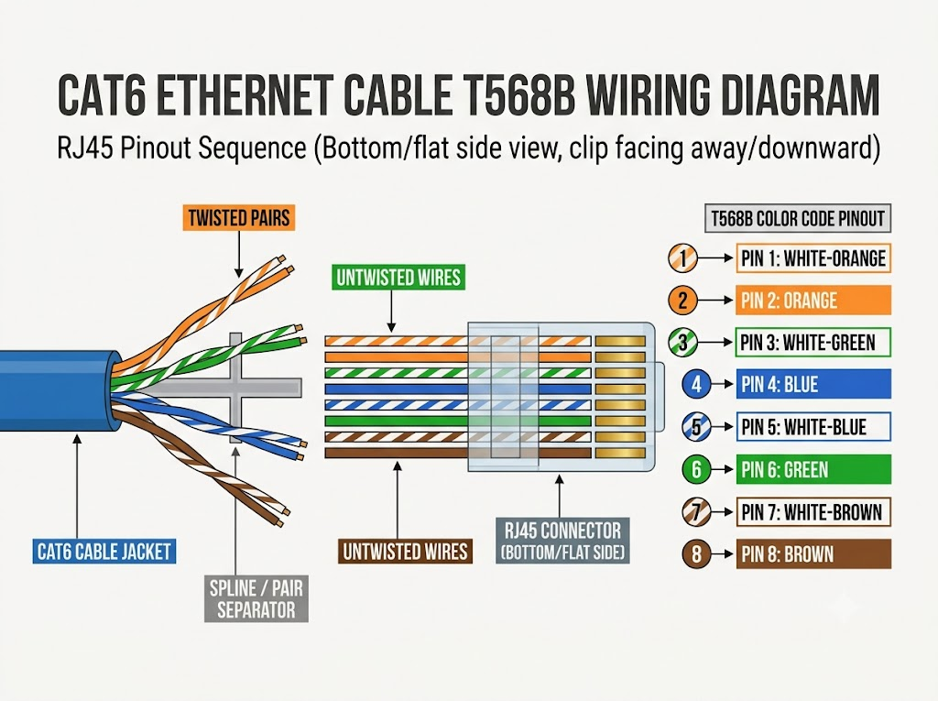
- List three types of network cables (such as Cat5e, Cat6, and fiber optic) and for each, mention one real-world app or device (like a WiFi router, Zomato POS terminal, or IPL streaming server) where it would be used, explaining why.

Cable Type | Real-World Use | Why
Cat5e | Home Wi-Fi router | Affordable and supports speeds up to 1 Gbps, suitable for most home internet connections.
Cat6 | Zomato POS terminal | Supports high-speed data transmission and offers reliable connectivity for payment transactions.
Fiber Optic | IPL streaming server | Provides very high bandwidth, supports long-distance transmission, and resists electromagnetic interference.

- Watch a YouTube video showing how to crimp an RJ-45 connector onto a network cable, then write down the step-by-step process in your own words and mention two common mistakes to avoid.

How to Crimp an RJ-45 Connector
Step-by-Step Process
Step | Action
1 | Cut the Ethernet cable to the desired length.
2 | Strip about 2 cm of the outer jacket.
3 | Untwist and separate the 8 wires.
4 | Arrange the wires in T568B order: Orange-White, Orange, Green-White, Blue, Blue-White, Green, Brown-White, Brown.
5 | Trim all wires evenly using a cable cutter.
6 | Insert the wires into the RJ-45 connector, ensuring all wires reach the end.
7 | Insert the connector into the crimping tool and squeeze firmly.
8 | Test the cable using an Ethernet cable tester.
Common Mistakes to Avoid
Mistake | Why It's Bad
Wrong wire order | The cable may fail to establish a proper connection or transmit data correctly.
Wires not pushed all the way in | The wires may not make proper contact with the connector pins, causing connection failure.

- Given the following scenario: You are setting up a gaming zone for an IPL screening event and need to connect multiple screens and consoles. Choose the appropriate cable and connector types for high-speed, reliable connections, and explain your choices.

IPL Gaming Zone Setup – Cable & Connector Choices
Connection Need | Cable Type | Connector | Reason
Console to Switch (LAN) | Cat6 | RJ-45 | Supports up to 10 Gbps over short distances (up to 55 m under suitable conditions) and provides reliable gaming connectivity.
Switch to Router / Screens | Cat6a | RJ-45 | Supports 10 Gbps up to 100 m and offers good protection against interference.
Long Distance (Across Hall) | Fiber Optic | LC / SC | Supports high-speed data transmission over long distances and resists electromagnetic interference.
Screen to Console (Video) | HDMI 2.1 | HDMI | Supports 4K resolution at up to 120 Hz with compatible devices.
Power Connections | Standard Power Cable | 3-Pin Plug | Supplies electrical power to screens and consoles.

- Find and share a photo (from your home, college, or online) of any network cable or connector in use (such as behind a WiFi router or at a café's POS counter), and describe what type it is and what devices it connects.<br><br><em><strong>Hint:</strong> Look for blue or yellow cables with clear plastic ends (RJ-45) or thin round cables for fiber optics.</em>

